## Configuration Essentials:

* Automation Test Scripts will be executed from Eclipse IDE.
* Script will be implemented by using Page Object Model Framework.
* Java used as scripting language.
* Java Test NG Framework used for the executing the test scripts.

## Configuration Steps:

* Create Workspace in Eclipse IDE.
* Copy the project from the available repository or the folder to the created workspace.
* Import the project to the Eclipse IDE. The below screen print shows the folder structure in the IDE.

# 

# Test Design Pattern implemented

**Package Name: com.sp.testscripts-** This is the main package,under this test suit is available to run this suit we are using testng.xml file

**Package Name: com.sp.pagefactory –** This is the main package that contains all the page classes meaning every class has the repository of their respective page objects.

Example:AddNewCustomer.java is the repository for the AddNewCustomer UI page.

**SPBase.java:** This is the base class for the entire project and all the subclasses extends this base class. The driver object will be initialized in this class only and all the reusable methods will be implemented in this class.

**DriverHome.java:**Every page under the pagefactory package will be initialized in this class using the page factory methods.

Example:

**public** Login getLogin(){

**return** PageFactory.*initElements*(*driver*, Login.**class**);

}

# Test Data import from external resource

**main.mp.testdata :** This package has the test data files in xlsx format. Data provider method reads the data from the file based on the test sheet and the test case names.

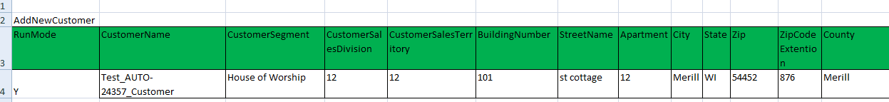

**Data Provider Method:**

Each and every test case is mapped with one data Provider method, inside the data provider name we have to pass respective sheet name along with test case, Data provider will pick all the test data , where Run Mode = ‘Y’ till it encounter first bank line.

Example:

@DataProvider

**public** Iterator<Object[]> getLogin() {

**return** Util.*getLoginData*("Login", xls).iterator();

}

As per the above method first parameter for Sheet Name and Second parameter is for test case name same will continue for all other methods.Test Execution Technique

## 6.1 Execution Steps:

* To Execute the project the below 2 files needs to be updated.

1. **application .Properties**

The properties file will be available in the below package:

**src/resources/application.properties:** Here we have to provide the URL of the application and browser name

1. **SPTestNG.xml:** This xml file is available under src with name testng.xml

right click on TestNG.xml file 🡪 Run As 🡪 Test NG suite. This runs all the test cases. in the testng.xml file update the test case names that needs to be executed. The test case names will be within the include tags.

**<includename=*"login"*/>**